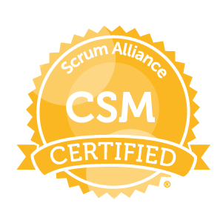
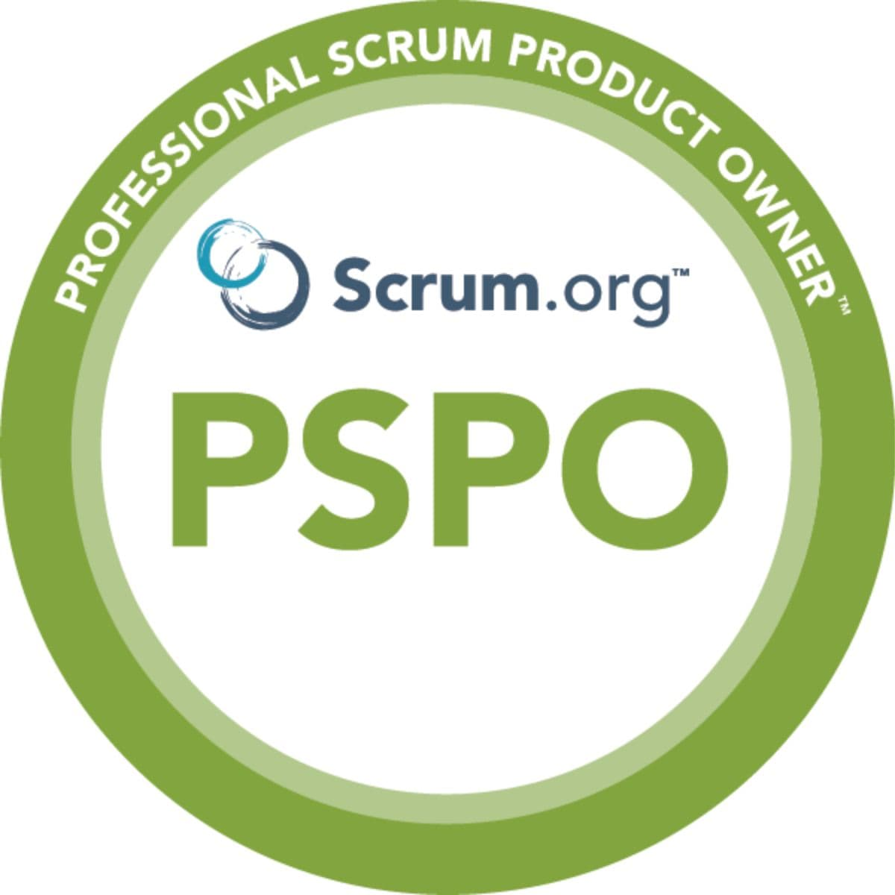
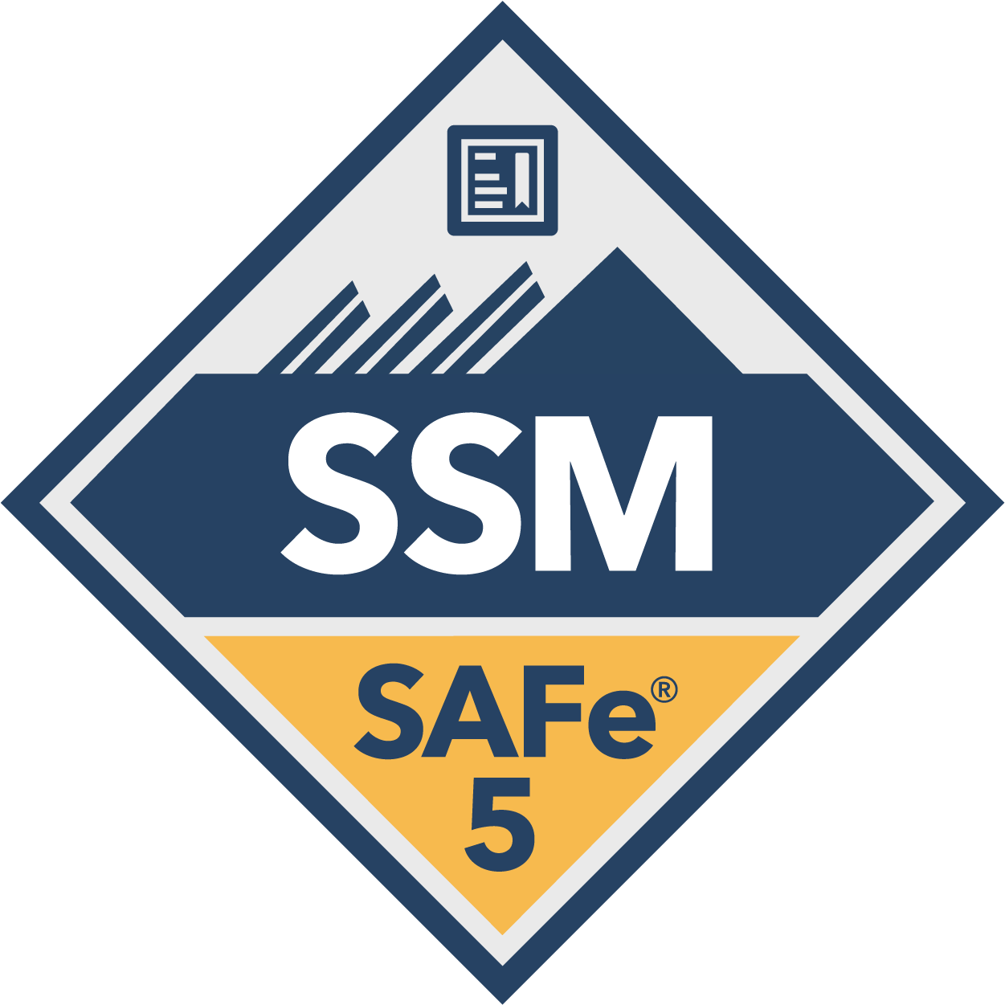

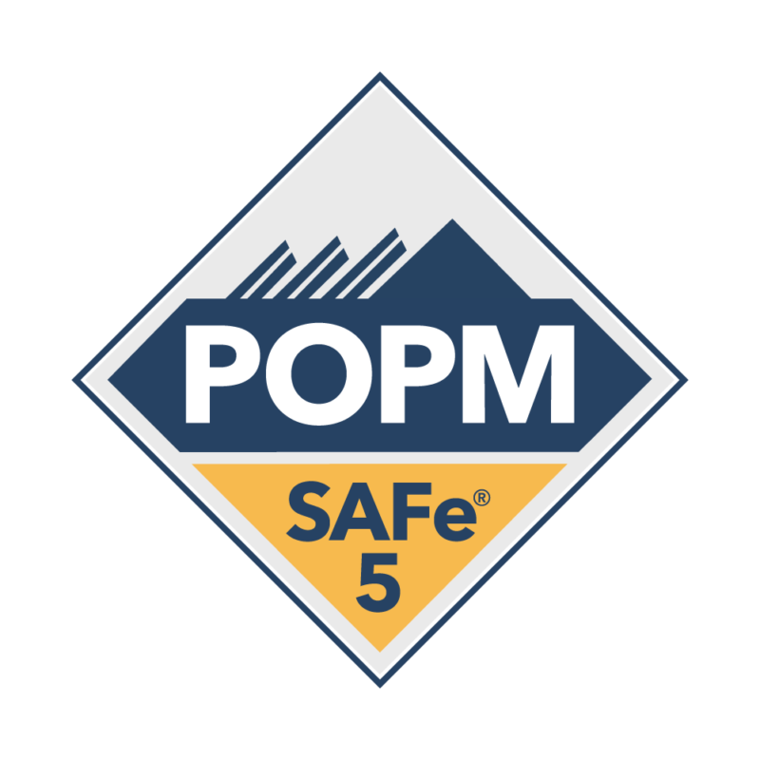
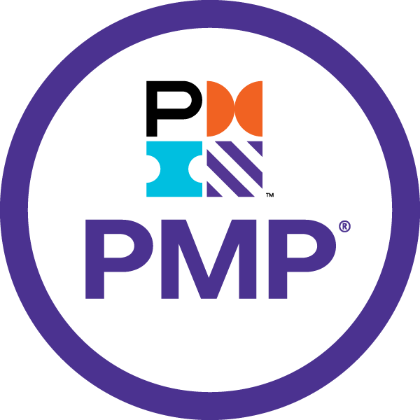

SOUJANYA MANNEPALLI
Senior Scrum Master /Senior Business Analyst

PROFESSIONAL SUMMARY:
- Senior Scrum Master cum Senior Business Analyst with a proven track record of over 10+ years of experience in healthcare, financial, insurance and pharmaceutical domain.
- Expertise at all phases of Software Development Life Cycle (SDLC) and Software Test Life Cycle (STLC) involving requirements gathering, analysis, functional design, testing and implementation.
- Business Analyst with extensive of experience with solid understanding of business requirement gathering, documentation, business process flow and business process modeling.
- Extensive experience in gathering Business/Functional user requirements, creating Use Cases as per user requirements, developing/designing UML diagrams such as Activity, Class, and Sequence diagrams in addition to creating Business Requirements Document.
- Extensive experience in gathering, analyzing, and validating business requirements in health insurance and health information systems.
- Defined external interface specifications for third-party integrations using RESTful APIs and XML/JSON formats.
- Assisted QA team in creating Test plans, Test Scenario and Test Cases for smoke, Functional, system integration and regression testing and coordinated UAT with the business users.
- Expertise in problem solving and bug tracking using Quality Center and Rational Clear Quest
- Extensive knowledge of different kinds of testing like User Acceptance Testing (UAT), Integration, System and Regression Testing.
- Experienced in developing functional and non-functional specifications, sequence diagrams, user interface designs and field level descriptions.
- Proactively managed requirement-related risks by maintaining a risk register and implementing mitigation strategies.
- Experience in performing ROI, Impact analysis, GAP Analysis and maintain Requirements Traceability Matrix (RTM) using Rational Requisite pro.
- Expertise in translating user requirements into System Specifications and mapping the process design, workflows for SDLC with documenting and managing business requirements.
- Strong knowledge and experience in performing systems integration using web services.
- Proficient in documenting high level system design including architecture requirements and conducted Technical Design Sessions.
- Extensive skills in developing Use Case diagrams, Sequence diagrams, Data Flow diagrams and Class diagrams.
- Experienced working in Cross-functional teams, identifying business requirements and supporting sales/marketing.
- Involved in project to understand the business needs and objectives of the system and interacted with the end client/ users and stakeholders, involved, and gathered requirements for the integrated system.
- Great interpersonal and communication skills, focused, self-motivated, organized, quick learner and team oriented.

EDUCATION & CERTIFICATION:
- Master’s in Business Administration (Banking and Insurance - Executive MBA), ANU
- Masters in Computer Applications (Cloud Computing – AWS, AZURE. Google), Jain University
- Master of Biotechnology (PSM program - Expertise into Gold/Red/White Biotechnology)), California State University, Fresno
- Bachelor of Engineering (Biotechnology), VTU
- Professional scrum product owner (PSPO)- Scrum org
- Certified Scrum Master – Scrum Alliance.
- Certified safe professional – POPM safe 5
- Certified Safe for teams professional - SP safe 5
- Certified safe scrum master - SSM safe 5
- Certified safe product management - APM safe 5
- PMP from PMI

TECHNICAL SKILLS:
Testing tools | QTP, Load Runner
Defect management tools | Quality Center, Clear Quest
Programming Languages | C, C++, SQL, Perl, Python, Java, HTML, CSS
Databases | MS SQL Server
Platforms | Windows 98/NT/2000/XP, Vista
Applications | MS Office Suite, MS Visio, MS Project, Rational, SharePoint, HRIS Suite Enterprise, Business Objects, TOAD, SAS, Netezza, Azure dev ops
Business Modeling Tools | UML CASE Tools, MS Visio, MS- Project
Business Intelligence tools | Business objects (Crystal, AO), Tableau, QV
Business Process Tools | Process Suite, Business Manager
Data Modeling Tools Platforms | Erwin, Rational rose, SAP HANA. Netezza
Bug Tracking Tools | HP ALM, Jira, Bugzilla
Methodologies | Agile-Scrum, Waterfall
Salesforce Expertise | Objects, Fields, Record Types, Validation Rules, Page Layouts, Triggers, Reports, Roles, Sharing Settings, Reports, Workflows, Communities, Lightning components, Visualforce.
Release Management Tools | JIRA, confluence, ADO
AWS | S3, IAM, EC2, Route53, ELB, Cloud watch, SNS

PROFESSIONAL EXPERIENCE:

Verizon, Irving Texas Dec 2023 – Present
Sr. Scrum Master/BA
Project Name: Sales Emerge (Telecommunication)

Responsibilities
- Worked to Analyze, design, develop and document ecommerce projects as per the user requirements
- Documented functional specifications, use case diagrams, and coordinated with technical architects for feasibility of solutions.
- Worked on supporting the technical team on technologies like Java, Angular and react.
- Worked on developing SQL queries for analyzing the data that was used in building the website portals.
- Worked closely with technical team on analyzing and preparing the JSON/XML samples
- Documented the “AS-IS” Business Workflows adhering to UML standards. Conducted JAD sessions to define requirements and finalize the Functional Requirement Document
- Facilitated User Acceptance Testing (UAT), ensuring that all errors were tracked and reported to development and management teams.
- Collaborated with developers to ensure engineering solutions aligned with business needs, including JSON/XML interface samples.
- Led UAT efforts and ensured thorough QA testing coverage across all modules.
- Led eCommerce initiatives, driving a 20% increase in sales acquisition through targeted online marketing strategies.
- Worked on projects that involved Artificial intelligence models/projects for building features that predicted the customer preference for perks for a given period.
- Knowledge on training a model on a labeled dataset tto predict the labels for unseen data.
- Analyzed VOC (Voice of the Customer) data to identify key areas for improvement in UI/UX, resulting in a 15% increase in conversion rates.
- Implemented customer feedback mechanisms to ensure all customer-focused actions are aligned with overall business objectives, enhancing customer satisfaction scores by 25%.
- Collaborated with cross-functional teams to optimize inventory management processes, ensuring accurate tracking and minimizing discrepancies.
- Spearheaded the development and execution of comprehensive e-commerce strategies that resulted in a 35% increase in Sales Acquisition over 12 months.
- Conducted in-depth analysis of transactional data to identify patterns and anomalies, enhancing the organization's ability to detect and prevent potentially fraudulent activities.
- Conducted thorough reviews of customer transactions, identifying and reporting suspicious activities to relevant authorities.
- Acted as single point of contact for multiple vendors, business units, and Information Technology partners during integration, administering schedules and communicating risks.
- Assisted with compliance, resulting in successful post-migration audit.
- Ran weekly meetings, helping to facilitate communication and maximize productivity.
- Created user stories and conducted sprint ceremonies and created dashboards for updating progress
- Identify and reconcile errors in client data to ensure accurate business requirements
- Identify risk related to business requirement implementation, testing process, and project communication and training for a better process.
- Ecommerce project where we ensured effective communication between system developer’s system, customers, and other stakeholders. Worked towards ensuring the website had the enhanced capabilities in terms if user experience.
- Developed and implemented test plans/scenarios to ensure successful delivery of a project
- Provided user training of developed features and after deployment support to users and maintenance team for potential issues.
- Maintained the integrity of various data processing procedures.
- Ensured the department maintains and executes standards to assure successful quality implementations.
- Responsible for the execution of quality process reviews and improvements to maintain and enhance departmental efficiencies through root cause analysis.
- Provided status and communication on projects to the next level of management
- Completed Integration testing of the Virtual Mobile devices with various Browsers and applications
- Escalated risk/issues to Product Owners/client managers and required stakeholders
- Environment: MS Office suite, Agile, Confluence, JIRA

SRS Distribution, Irving, Texas May 2023 – Dec 2023
Sr. Scrum Master/BA
Project Name: Aquaship Portal (Supply chain/E-commerce)

Responsibilities
- Analyzed and documented business requirements for supply chain projects, translating them into functional specifications for development teams.
- Assisted in the development and execution of test plans to ensure the quality and functionality of new supply chain solutions.
- Worked closely with stakeholders to identify pain points and recommend solutions to improve supply chain processes.
- Conducted data analysis to identify trends and insights, supporting decision-making and strategic planning.
- Facilitated training sessions for end-users, ensuring smooth adoption of new systems and processes.
- Spearheaded the implementation of a new inventory management system, reducing stockouts by 30% and excess inventory by 25%.
- Gathered and documented business requirements for supply chain optimization and inventory management systems.
- Managed a cross-functional team of developers, designers, and QA engineers to deliver high-quality products on time and within budget.
- Engaged with key stakeholders to gather requirements, define user stories, and prioritize features based on business value and user feedback.
- Developed and maintained detailed project plans, tracking progress against milestones and ensuring timely communication of project status to stakeholders.
- Implemented process improvements that streamlined supply chain operations, resulting in a 10% increase in overall efficiency.
- Environment: MS Office suite, Agile, Confluence, JIRA

SNP Global (Finance), NYC, NY/Remote Jun 2020 – May 2023
Sr. Scrum Master/BA
Project Name: Analytical tools

Responsibilities
- Defined and documented project scope, detailed business requirements and system design specifications after structured analysis of user needs, existing and proposed business systems
- Understand Product Requirements and convert those into functional requirements/specifications while ensuring they are in line with the business objectives.
- I worked closely with cross-functional teams including Treasury, Operations, and Technology departments to understand their specific needs and requirements. By fostering effective communication and collaboration between these teams, I facilitated the smooth integration and utilization of Treasury applications and products.
- By collaborating with different teams and leveraging my expertise in Treasury applications and products, I contributed to the successful implementation, leading to improved business outcomes and enhanced operational efficiency within the organization.
- Conducted Gap analysis with client requirements to ensure that the proposed model/solution is supported by the system.
- Carry out feasibility studies and coordinate with technical teams to complete acceptance criteria and provide support to develop/enhance the product.
- Managed product backlog in Azure DevOps and acted as proxy product owner during sprint planning.
- Collaborated with QA teams to ensure comprehensive test coverage and defect resolution.
- Managing product backlog in Azure dev ops and, creating and grooming user stories, creating wireframes, resolving cross functional dependencies, and collaborating with development and quality control teams for effective product release
- Worked in collaboration with QA (Quality Assurance) team to review all the test scenarios and test cases to ensure maximum coverage of business functionality.
- Ensured a seamless communication between the offshore development and quality assurance teams and the project stakeholders both on-site and off-site.
- Facilitating and mentoring teams to understand and work with scrum in addition to carrying out scrum ceremonies.
- Coordinating with development, testing and support team during and post development of IT solution.
- Well coached and mentor the Agile team members and provides constructive performance feedback to ensure successful sprints.
- Extensive experience configuring and designing the Salesforce.com CRM solution to meet business requirements and support existing business processes.
- Experience designing and deploying solutions that optimized cloud functionality and lead the implementation of these solutions.
- Performed quality assurance, system integration and user acceptance testing facilitating on-time, on-budget and acclaimed “go-live” of enterprise implementations for up to over thousands of global users.
Environment: MS Office suite, Agile, Azure Devops

Honda (Automobile), Dallas, TX/Remote Aug 2019 – May 2020
Sr. Scrum Master
Project Name: Honda Project

Responsibilities
- Worked to Analyze, design, develop and document new projects as per the user requirements.
- Documented functional specifications, use case diagrams, and coordinated with technical architects for feasibility of solutions.
- Documented the “AS-IS” Business Workflows adhering to UML standards. Conducted JAD sessions to define requirements and finalize the Functional Requirement Document
- Meet with key stakeholders to gather detailed business and functional requirements to be built into Salesforce.com.
- Created user stories and conducted sprint ceremonies and created dashboards for updating progress.
- Identify and reconcile errors in client data to ensure accurate business requirements.
- Identify risk related to business requirement implementation, testing process, and project communication and training for a better process.
- Facilitated communication between system developer’s system, customers, and other stakeholders.
- Developed and implemented test plans/scenarios to ensure successful delivery of a project.
- Provided user training of developed features and after deployment support to users and maintenance team for potential issues.
- Maintained the integrity of various data processing procedures.
- Ensured the department maintains and executes standards to assure successful quality implementations.
- Responsible for the execution of quality process reviews and improvements to maintain and enhance departmental efficiencies through root cause analysis.
- Provided status and communication on projects to the next level of management.
- Completed Integration testing of the Virtual Mobile devices with various Browsers and applications.
- Testing - Functional Testing, Browser Compatibility Testing, Regression Testing
- Escalated risk/issues to Product Owners/client managers and required stakeholders.
Environment: MS Office suite, Agile, Confluence, JIRA

Bayat (E-commerce), Dallas, TX/Remote Jul 2016 – Jul 2019
Sr. Business analyst/Scrum Master
Project Name: Bayat Hotels

Responsibilities
- Involved in gathering requirements, created user stories, and provided quality testing for the application.
- Created user stories and conducted sprint ceremonies and created dashboards for updating progress.
- Responsible for the implementation of applications within the organization.
- Discussed and covered all the points mentioned in the Requirements template with the Operations team to capture Requirements efficiently.
- Reviewed requirements with operations and obtain sign off on the requirements.
- Communicated scope changes with all project stakeholders via email and capture it in the system in IT Resources Tab for future tracking purposes.
- Requested legally approved letters from OPS.
- Assisted in cross-training enterprise change management associates responsible for other platforms.
- Facilitated communication between system developer’s system, customers, and other stakeholders.
- Maintained the integrity of various data processing procedures.
- Ensured the department maintains and executes standards to assure successful quality implementations.
- Updated the applicable tracking system status reports and various matrices.
- Facilitated the understanding and use of change management best practices procedures and methodologies to application development teams.
- Assisted in the facilitation of change notification to the end-user community.
- Implemented and maintained industry standards for software configuration management.
- Responsible for the execution of quality process reviews and improvements to maintain and enhance departmental efficiencies through root cause analysis.
- Provided status and communication on projects to the next level of management.
- Provided on-call support for enterprise change management functions for all supported platforms.
- Compiled with all appropriate policies procedures and safety rules and regulations.
- Environment: MS Office suite, SQL, MS Project, MS PowerPoint, Agile, UAT SharePoint, Asana
Environment: MS Office suite, SQL, Business process mapping, MS Project, MS Visio, Requisite Pro

Deloitte (Finance), Nashville, TN Oct 2015 - Mar 2016
Scrum Master /Business Analyst
Project Description: Trading and tracking system, As business analyst, was responsible for coordinating project that involved development of an automated application that can generate a reliable list of professionals that are likely in conflict with the personal financial interest. This involved merging of different systems of information (DTE, TT DESC) into a single reporting platform in order to find conflicts of interest between personal financial interest and charged time to a restricted entity.

Responsibilities
- Involve in gathering requirements, creating user stories and also providing quality testing for the application.
- Created user stories and conducted sprint ceremonies and created dashboards for updating progress.
- Develop timelines for project delivery, and managed projects and resources to successful completion.
- Work with the software architects/developers to ensure that the application conforms to customer requirement.
- Conduct JAD sessions between the end users and the development team.
- Translate the business needs into system requirements and communicated with the business on a non-technical level.
- Gather and analyze business requirements, perform gap analysis and document them textually and within models.
- Work with the software architects/developers to ensure that the application conforms to customer requirements.
- Produce professional quality project artifacts including but not limited to business requirement documents, requirement plans, models, traceability matrices and other documents as needed.
- Work with QA team to design test plan and test cases. Participated in execution of unit, integration and User Acceptance Testing (UAT) to meet business requirements.
- Coordinate with Quality Assurance offshore / onshore team for the assigned initiative.
- Advise and recommended areas of program planning, business management, and program coordination.
- Develop Use Case Models, Activity Flow and Business process flow for financial applications within the company.
- Design systems to collect financial business-related data to meet regulatory and compliance requirements.
Environment: SAP HANA, Tableau, QV, Business Objects (Xcelsius, Crystal report) Microsoft BI tools (SSRS), BW Methodology – Agile

Humana (Healthcare/Pharma), Louisville, KY Jan 2014 – Nov 2014
Scrum Master/Business Analyst

Project description: Medicaid inventory management, As enterprise data analyst involved in coordination and requirement analysis on multiple projects like ICD -10 to 9 backwards mapping, segmentation MA plans, Pop health phase 3, Medicaid Data Inventory Mapping, ICD-10 Project for TSG applications and SAS and Netezza production support. As Business analyst, was responsible for coordinating with customer and IT teams on various requirements. These projects involved enterprise-wide testing to ensure the proper flow of segment data, ICD 10 to 9 backward mapped data through all systems. This includes any new edits, job processes, reports, and benefit display that may be impacted.

Responsibilities
- An agile/waterfall approach was used to coordinate and complete projects before the expected timelines.
- Liaised with business and functional owner during risk engineering and high-level review sessions to derive and execute action plans, meeting deadlines and standards.
- Conducted sprint ceremonies and created dashboards for updating progress.
- Interfaced with business users to prepare and update Business Process Requirements (BPR) and Software System Requirements (SSR). Created test cases and test scripts.
- Did active Market scanning to identify to identify customer needs, anticipate competitive actions, and identify technological changes which will provide new market opportunities or market disruptions
- Prioritized outstanding defects and system problems, ensuring accuracy and deadlines were met.
- Analysed new predictive models like DCM, NMPM and trending processes for various projects.
- Worked with architects and test lead to translate requirements into technical specifications.
- Did Competitive analysis involving identification of direct and indirect competitors using research to reveal their strengths and weaknesses in relation to your own.
- Produced professional quality project artifacts including but not limited to business requirement documents, requirement plans, models, traceability matrices and other documents as needed.
- Validated technical designs created by IT developers against functional specifications.
- Applied change requests, versions, and addendums.
Environment: MS office suite, SQL, SAS, Netezza

Sammons Financial Group, Sioux Falls, SD Mar 2013 – Dec 2013
Business Analyst
Project description: Customer workflow system, The project involved planning, reviewing, and implementation of the Customer Workflow System to provide a paperless workflow of all current processes, automated metrics reporting, and simplified routing of requests. Designed and implemented BPM application Bonita to develop the current process which included requests from the call center. In addition, we were accountable for determining the detailed scope of the project and developing the high-level test scripts to be used by the various test teams (business & IT).

Responsibilities
- An Agile approach was followed throughout the software implementation cycle.
- Implemented paperless workflow application to develop the current process which would include requests from the call center.
- Created dashboard metrics for tracking requests and added the capability to prioritize a specific work request.
- As BA, allowed the business to define roles and assign individuals to those roles.
- Provided metrics breakdown for productivity, trending issues, and estimated costs of a process.
- Created and participated in system tests of the project.
- Managed linkage and interface among various systems that support business.
- Performed Gap Analysis of the as-is and should-be processes to identify and validate requirements.
- Organized requirements into Use Cases and modeled them into UC, Activity, Sequence and Collaboration diagrams using Rational Rose and MS Visio.
- Attained formal sign-off by the business owners and IT delivery senior management that the aims and objectives have been met and that the ‘end of project’ report has been produced and the “lessons learned” are documented and disseminated.
- Managed and reported the defects in Jira with proper priority and severity.
- Actively participated in status reporting meetings and interacted with development to discuss technical issues.

Environment: MS Office suite, SQL, Business process mapping, MS Project, MS Visio, Requisite Pro, QTP.10, JIRA, Loadrunner.

Kaiser Permanente (Healthcare/Pharma), Fremont, CA Feb 2011 – Mar 2013
Business Analyst

Project Description: ICD 9 to ICD 10 conversion, The goal of the project is to plan the ICD-10 End to End Testing, which was established by program executives to provide companywide test standards and oversight for the ICD-10 program. In addition, we are accountable for determining the detailed scope of End to End (E2E) testing and developing the high-level test scripts to be used by the various test teams (business & IT). E2E testing refers to the final phase of testing for the ICD-10 program when all application changes have been made and connectivity across the applications has been established in the test environments. We used a risk-based test approach. This approach identifies risks related to applications and business processes specific to ICD-10. These risks are then detailed and translated into test scenarios describing the details of what will need to be tested.

Responsibilities
- Waterfall SDLC methodology was followed throughout software implementation cycle.
- Coordinated with onsite teams during the project implementation period for development and testing activities.
- Coordinated extensive JAD sessions with design, development, DBA’s and SME’s to tree down the business requirements into functional requirements.
- Co- coordinated with the business end-users in elicitation of risk requirements for perform E2E.
- Performed GAP analysis, reviews, audits and analyzed system effectiveness in meeting the requirement.
- Aligned with testing PMO governance policies and managed the various expectations across the program.
- Developed Use Case Models, Activity Flow, Business process flow, Sequence and well documented for future reference.
- Extensively used medical terminology, medical coding (CPT-4, HCPCS, and ICD-9/10), APC, DRG in claim processing, 4010, 5010.
- Applied UML notations and methodology in developing models that accurately represent the business process and workflows and clearly communicate them to the stakeholders.
- Excellent understanding of professional and institutional hospital billing
- Designed systems to collect healthcare business related data to meet regulatory and compliance requirements.
- Executed various SQL queries to perform data validation and check data integrity.
Environment: MS Office suite, MS Project, Visio, Rational Clear Quest

DFA, CA (Healthcare/Pharma), Fresno, CA Jan 2010 – Jan 2011
Business Analyst

Project Description: DFA laboratories are ISO/IEC 17025 accredited through the American Association for Laboratory Accreditation – A2LA. ISO accreditation ensures that the laboratory meets stringent technical requirements by virtue of routine audits by A2LA, participates in proficiency testing programs, and proves competencies through vertical and horizontal traceability check of documentation. Our projects revolved around experimental fumigants that are continuously being tested to determine insect mortality and their potential application within the food industry.

Responsibilities
- Proactively participated in project management, defined the scope of the project, gathered and analyzed business requirements, performed gap analysis and documented them textually and within models.
- Responsible for authoring and managing execution of functional verification and User Acceptance Testing (FV/UAT) test plan, test cases and test summary reports.
- Conducted JAD sessions and requirements gathering sessions with various stake holders of the project.
- Performed business process mapping, correlating existing systems to new systems and identify systems to be validated under 21 CFR Part 11
- Actively communicated with validation manager in understanding and delegating the requirements for validation of Labware LIMS–Millennium32 /Empower, DeltaV and Syncade
- Developed Traceability Matrix based on UFRS.
- Used Documentum (Document Management System) for document control, management, audit management, out of specification/non-compliance tracking, CAPA as part of change control and revalidation.
- Assured that all the validation documents, namely IQ, OQ and PQ documents conform to the GMP specifications.

Environment: MS Office suite, SQL, Business process mapping, MS Project, MS Visio, Requisite Pro

